
I
REPUBLIC OF CAMEROON
*****
Peace-Work-Fatherland
*****
CENTER REGION
*****
ADVENTIST UNIVERSITY COSENDAI
OF NANGA-EBOKO
*****
DEPARTMENT OF MANAGEMENT AND INFORMATION TECHNOLOGY

REPUBLIQUE DU CAMEROUN
*****
Paix-Travail-Patrie
*****
REGION DU CENTRE
*****
UNIVERSITE ADVENTISTE COSENDAI
DE NANGA-EBOKO
*****
FACULTE DE GESTION ET INFORMATIQUE

TOPIC : KEYBOARD AND KEYBOARD OPERATION

NOM ET PRENOM | MATRICULE
AWONO ALARA MARLEINE VANESSA | L2023GLSI0148
CHIKABOU JACQUES | L2023GLSI0149
MVOMO EBOLO MARTIN | L2023GLSI0139
MEDJO HELVADOR BENJAMIN | L2023GLSI032

EXAMINER : Mr PETER LANDOH
ANNEE ACADEMIQUE : 2024/2025

PRESENTATION OUTLINE
INTRODUCTION
- STRUCTURE AND COMPOSITION OF THE KEYBOARD
- Main keys
- Keyboard layouts
- Technologies used
- HOW THE KEYBOARD WORKS
- Electrical signal
- Signal conversion
- Connection interface
- OPERATIONS WHIT THE KEYBOARD
- Text input
- System commands
- Custom shortcuts
- Macros
- Gaming
- Accessibility
- RECEENT INNOVATIONS
- Ergonomic keyboards
- Backlit keyboard
- Touch Technology
- Smart keyboards
- MAINTENANCE AND BEST PRATICES
- Cleaning
- Avoid liquids
- Ergonomic positioning
Conclusion

INTRODUCTION

The keyboard is an essential input device for computers, tablets, and even some smartphones. It is used to transmit textual information, commands, and shortcuts to the system. Initially invented for typewriters, it has evolved into an indispensable tool in the field of computing. The keyboard is one of the most widely used input devices in computer.

I. STRUCTURE AND COMPOSITION OF THE KEYBOARD
The keyboard consists of several functional parts
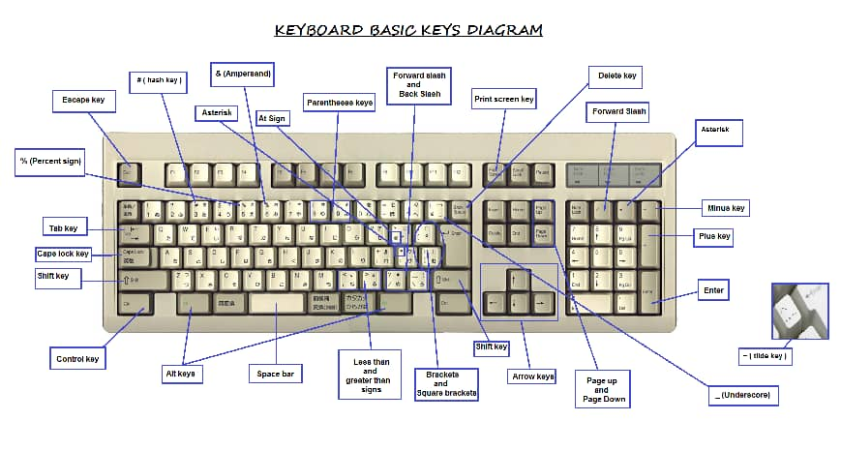

1. Main Keys
- Alphanumeric Keys: Include letters, numbers, and special characters such as #, %, or &.
- Function Keys: Usually located at the top (F1 to F12), they execute specific commands depending on the context.
- Navigation Keys: Include directional arrows, Page Up, Page Down, Home, and End.
- Numeric Keypad: Used for quick numerical input and calculations.

2. Keyboard Layouts:
AZERTY: Used mainly in France and other French-speaking countries.
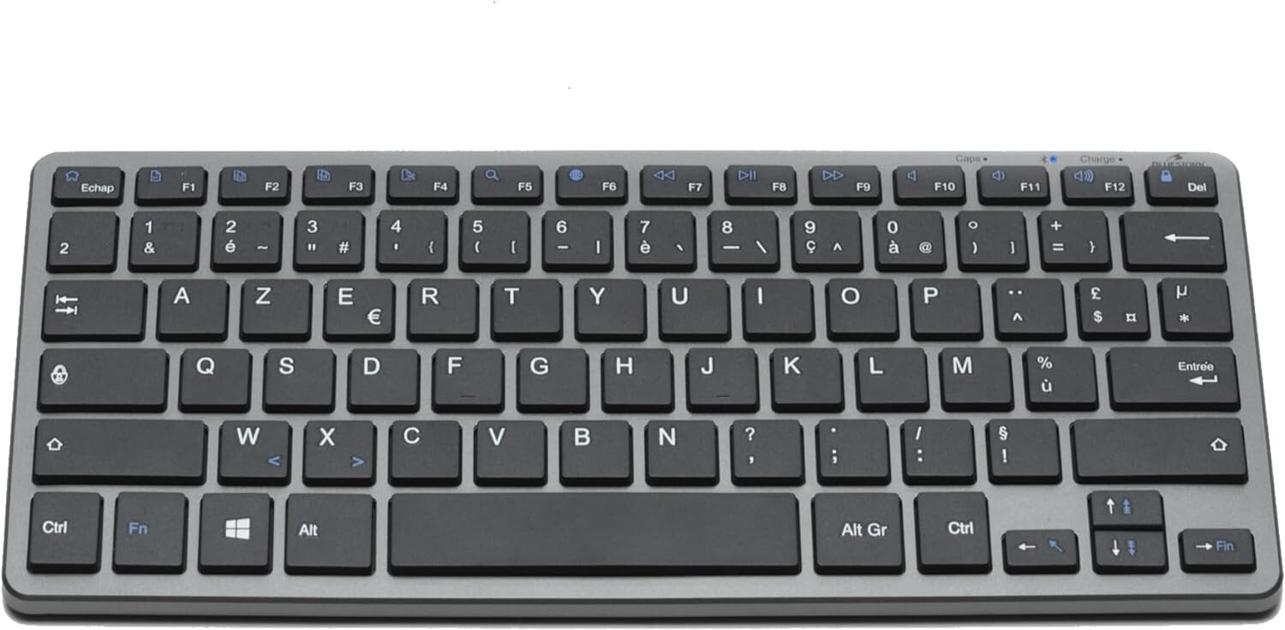

QWERTY: Standard in North America and many English-speaking countries.
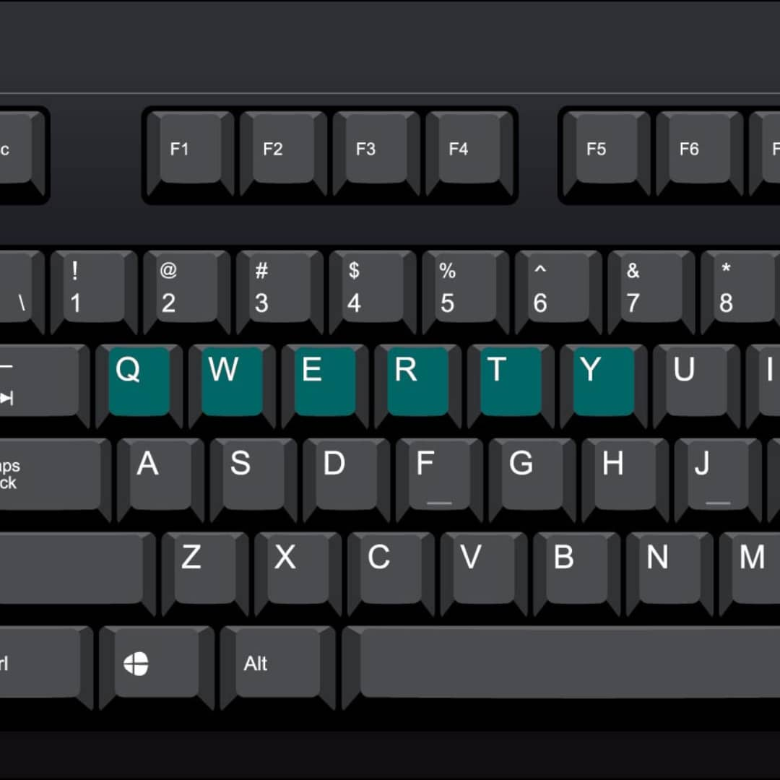

QWERTZ: Common in German-speaking countries.
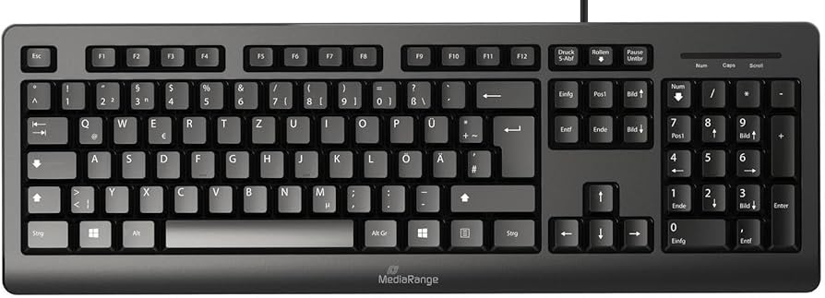

Other layouts: Ergonomic keyboards, Dvorak, or Bépo for increased efficiency.

3. Technologies Used

Mechanical Keyboards: Use individual switches for each key, offering durability and tactile feedback.

Membrane Keyboards: Cheaper and quieter but less durable.These keyboards use asingle layer of conductive material underneath the keys.

Virtual Keyboards: Integrated into touchscreens. Used in a touch sensitive surface to input data.
Wired keyboard: These keyboards connect to the computer via a physical cable.
Wireless Keyboard : These keyboards connect to the computer via Bluetooth or radio frequency signals.

II. HOW THE KEYBOARD WORKS

- Electrical Signal
Each key is connected to an electrical circuit. Pressing a key closes a circuit, generating a specific signal sent to the computer.

- Signal Conversion
The signal is converted into binary code by a controller embedded in the keyboard.

This code is then interpreted by the operating system to execute the corresponding action (display a character, activate a command, etc.).

- Connection Interface
USB: Modern standard for wired keyboards.

Bluetooth: Enables wireless connectivity for greater mobility.

PS/2: An older standard still used in some industrial environments.

III. OPERATIONS WITH THE KEYBOARD

- Text Input
The most basic use of the keyboard, involving the entry of characters and numbers.

- System Commands
Use of combinations like Ctrl+C (copy) or Ctrl+V (paste).
Shortcuts to open menus, launch programs, or switch between windows.
- Custom Shortcuts
Some software allows users to configure specific shortcuts to enhance productivity.
A custom shortcut is a tailored key combination or botton that enables users to perform a particular task or action with increased efficiency and speed.ex CTRL+Shift+f to open a file,

- Macros
A sequence of keys can be recorded to perform complex tasks with a single action.

- Gaming
Gaming keyboards feature programmable keys, RGB lighting, and anti-ghosting (to detect multiple keys pressed simultaneously).

- Accessibillity
Features such as virtual keyboards, sticky keys, or Braille keyboards for individuals with specific needs.

IV. RECENT INNOVATIONS

- Ergonomic Keyboards
Designed to reduce fatigue and prevent musculoskeletal disorders.
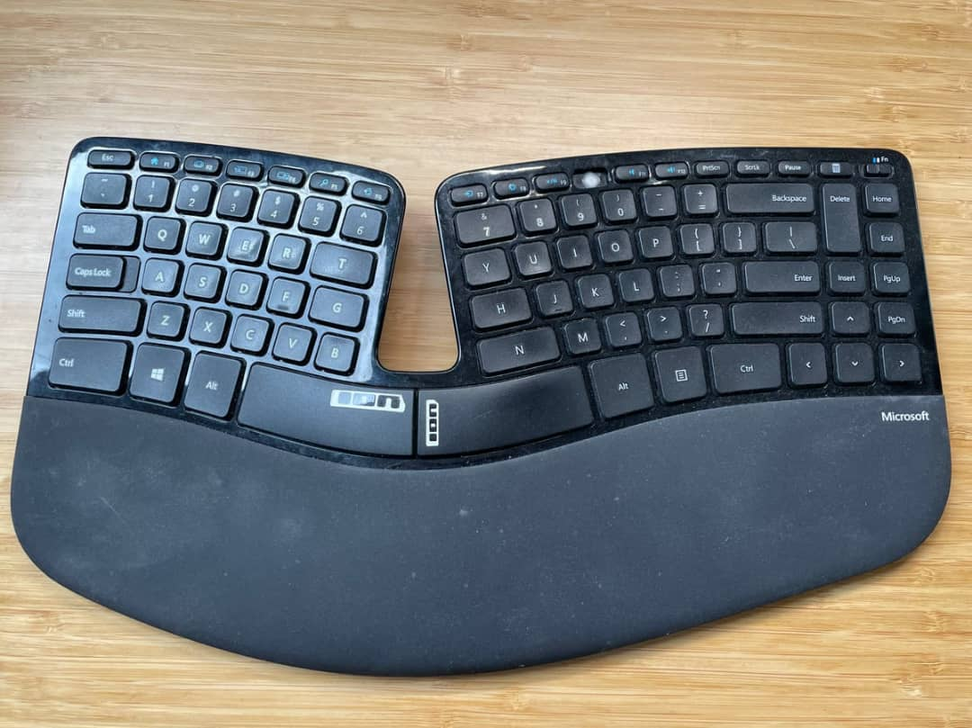

- Backlit Keyboards
Useful in low-light environments.


- Touch Technology
Touchscreens sometimes replace physical keyboards, especially on smartphones and tablets.
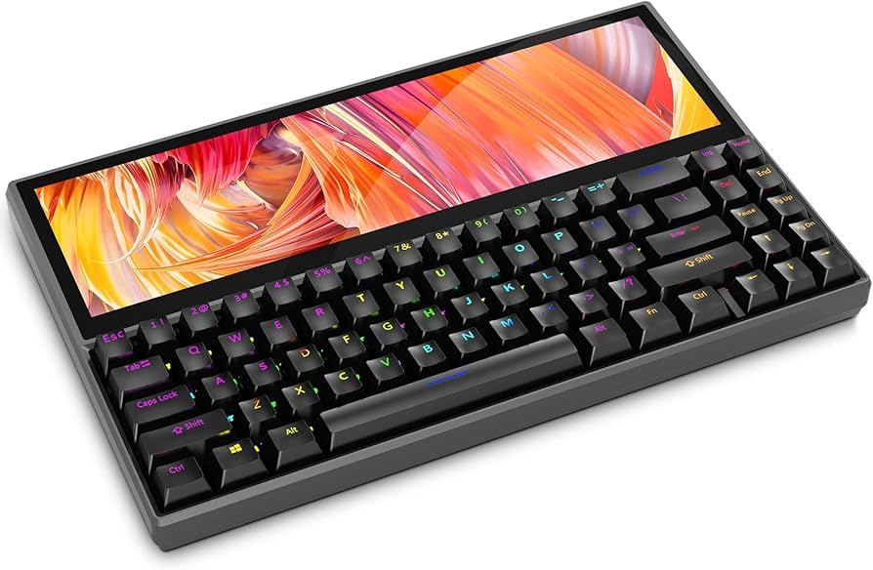

- Smart Keyboards
Integration of artificial intelligence for text prediction or automatic correction.

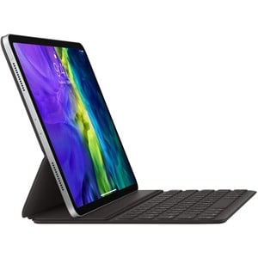

V. MAINTENANCE AND BEST PRACTICES

- Cleaning
Regularly dust with a blower or compressed air canister. Clean the keys with a slightly damp cloth.

- Avoid Liquids
Protect the keyboard from spills and splashes.

- Ergonomic Positioning
Adjust the height and tilt to avoid wrist pain.

CONCLUSION

The keyboard is far more than a simple typing tool. It is a versatile device that continues to evolve to meet the needs of users, whether they are professionals, gamers, or casual users. Understanding its functionality and optimizing. its use can significantly enhance efficiency and comfort.

